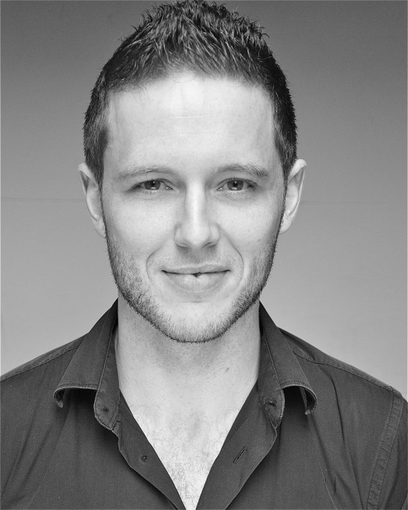
Matthew Forsythe
Equity: A00315831
Spotlight: 4777-9057-5916
Rosebery Management
87 Leonard St, Shoreditch, London EC2A 4QS
E Mail: admin@roseberymanagement.com
Tel: 020 7684 0187

Height: 5’ 9” Weight: 12 stone 5lb
Hair Colour: Brown Eye Colour: Blue
Playing age: 25-33

Training
Drama Studio London: Two year postgraduate acting course 2009-2011

London College of Music: Licentiate Diploma in Musical Theatre 2008

Professional Theatre
Keith/Mick/Ian U/S Our Boys David Grindley Duchess Theatre
Smirnov/Driver/Kemyshev Chekhov Vaudevilles Jenny Eastop Brockley Jack
Willoughby/Ferrars U/S Sense And Sensibility Helen Tennison Rosemary Branch/Tour
Whip The Hang of the Gaol Doug Rollins Brockley Jack Theatre
Prologue Henry the Fifth Opening ceremony, RST Stratford Greg Doran RSC Stratford
Steve If it’s a Boy Cristin McAuley Belvoir Players Theatre

Theatre While Training
Jack McCracken A Small Family Business Peter Craze Camden Peoples Theatre
Daniel My Night With Reg Jenny Eastop Grange Court Theatre
Sir Richard Kato The Case of Rebellious Susan Geoffrey Beevers Grange Court Theatre
Astrov Uncle Vanya Chris Pickles Grange Court Theatre
Benedick Much Ado About Nothing Ken Bentley Grange Court Theatre

TV
Jack Tolerance Magnus Ahlberg Short Film
Jarvis Just Keep Floating Josh Harris Short Film
Stuart Sunday Best David Tucker Short Film

Workshop
TV: Period drama/soaps David Tuckers, Mary McMurry. Radio: Radio Drama Jilly Bond.
Sketch Shows/Sitcoms, Jeremy wooding Voice Overs, Simon Mattacks
Voice and Speech: Rikke Liljenberg, Tessa Woods, Dewi Hughes Singing: Sarah Stephenson,
Acting: Helen Tennison, Brendan Murray, Illona Linthwaite Shakespeare Workshop: Chris Pickles, Crispin
Stage Combat: Philip D’Orleans Harris
Clowning/Mask: Forbidden Theatre Company

Skills
Trained Tenor, Basic dance, Writing, Stage Combat, A member of BASSC (British Academy of Stage and Screen) Football, Swimming, Horse Riding, basic Golf.
Carpenter and Joiner. Clean Driving License.

Accent
Belfast (native), Dublin, Irish-Northern, RP, Cockney, General American, Liverpool, Northern.

