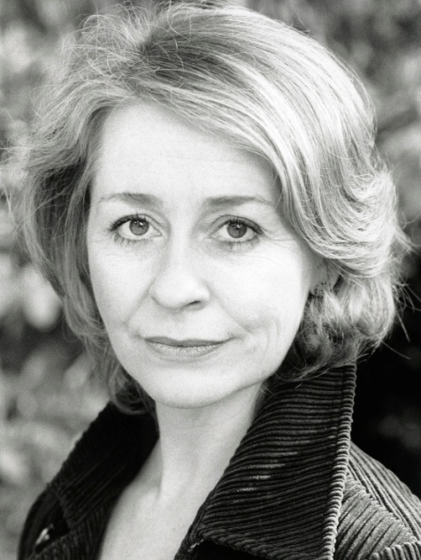
SHARON COADE
AGENT: HALINA FROUDIST
ACTORS & MOVERS
00353 87 9956353

Height: 5 2” Hair: Blond Eyes: Brown Playing Age: 31 – 45 years

STAGE
2009 Matron, BE MY BABY, Lyric Theatre Belfast, Anna Newell
2007 Jeanne, THE DRESS, Dublin Gay Theatre Festival, Simon Hudson
2006 Julie, FIENDS REUNITED, Sweet & Dry Theatre Co., Jim Martini
2005 Various, YEATS SEASON, Dublin Lyric Players, National Library, Conor O’Malley
2002 Irene Ruddock, A LADY OF LETTERS, New Theatre, Sean Leahy
2002 Jolly, THE OLD NEIGHBORHOOD, Sweet & Dry Theatre Co., Jim Martini
1993 Felicity, HABEAS CORPUS, Samuel Beckett Theatre, Dave O’Brien
1989 Fairy Godmother, SNOW WHITE, Albemarle/Olympia Theatre, Basil Critchley
1989 Niamh, WAR, Passion Machine/Olympia Theatre, Paul Mercier
1986 Kathy, THE YOUNG EUROPEANS, National Youth Theatre, Gerry Stembridge
FILM & TELEVISION
2008 Mrs. Shepard, AWARENESS, Medium Pictures, John Quinn (short)
2007-8 Maeve Bergin, FAIR CITY, RTE,
2003 Young wife, LAWS OF ATTRACTION, Irish Dreamtime, Peter Howitt
MUSICAL
1996 Young Margie, FOLLIES, National Concert Hall, Michael Scott
1994 Various, BROADWAY BABIES, Guilty Pink Productions/NCH
COMMERCIAL
2007 Mother, Road Safety Authority, Syd Macartney
2006 Wife, Power of One Energy, Tim Royes
2005 Airport Shopper, Procter & Gamble, John Hayes
2003 Board Member, Vodafone, H2 Films
2002 Shopper, An Post, Des Mullan

TRAINING & SKILLS
Stanislavski System with Deirdre O’Connell at the Focus Theatre Dublin
Musical Theatre with Gillyanne Kayes (VOCAL PROCESS) London
Workshops: Central School of Speech & Drama (Musical Theatre, Text & Voice)
Actors Centre London (Sightreading, Camera Technique)
Screen Training Ireland (Mark Travis – Actor & Director in rehearsal)

Singer – Musical Theatre, Jazz, Cabaret – Strong Belt
Movement and Dance
Good range of Accents and Dialects

