Pàdraig J. Dunne.
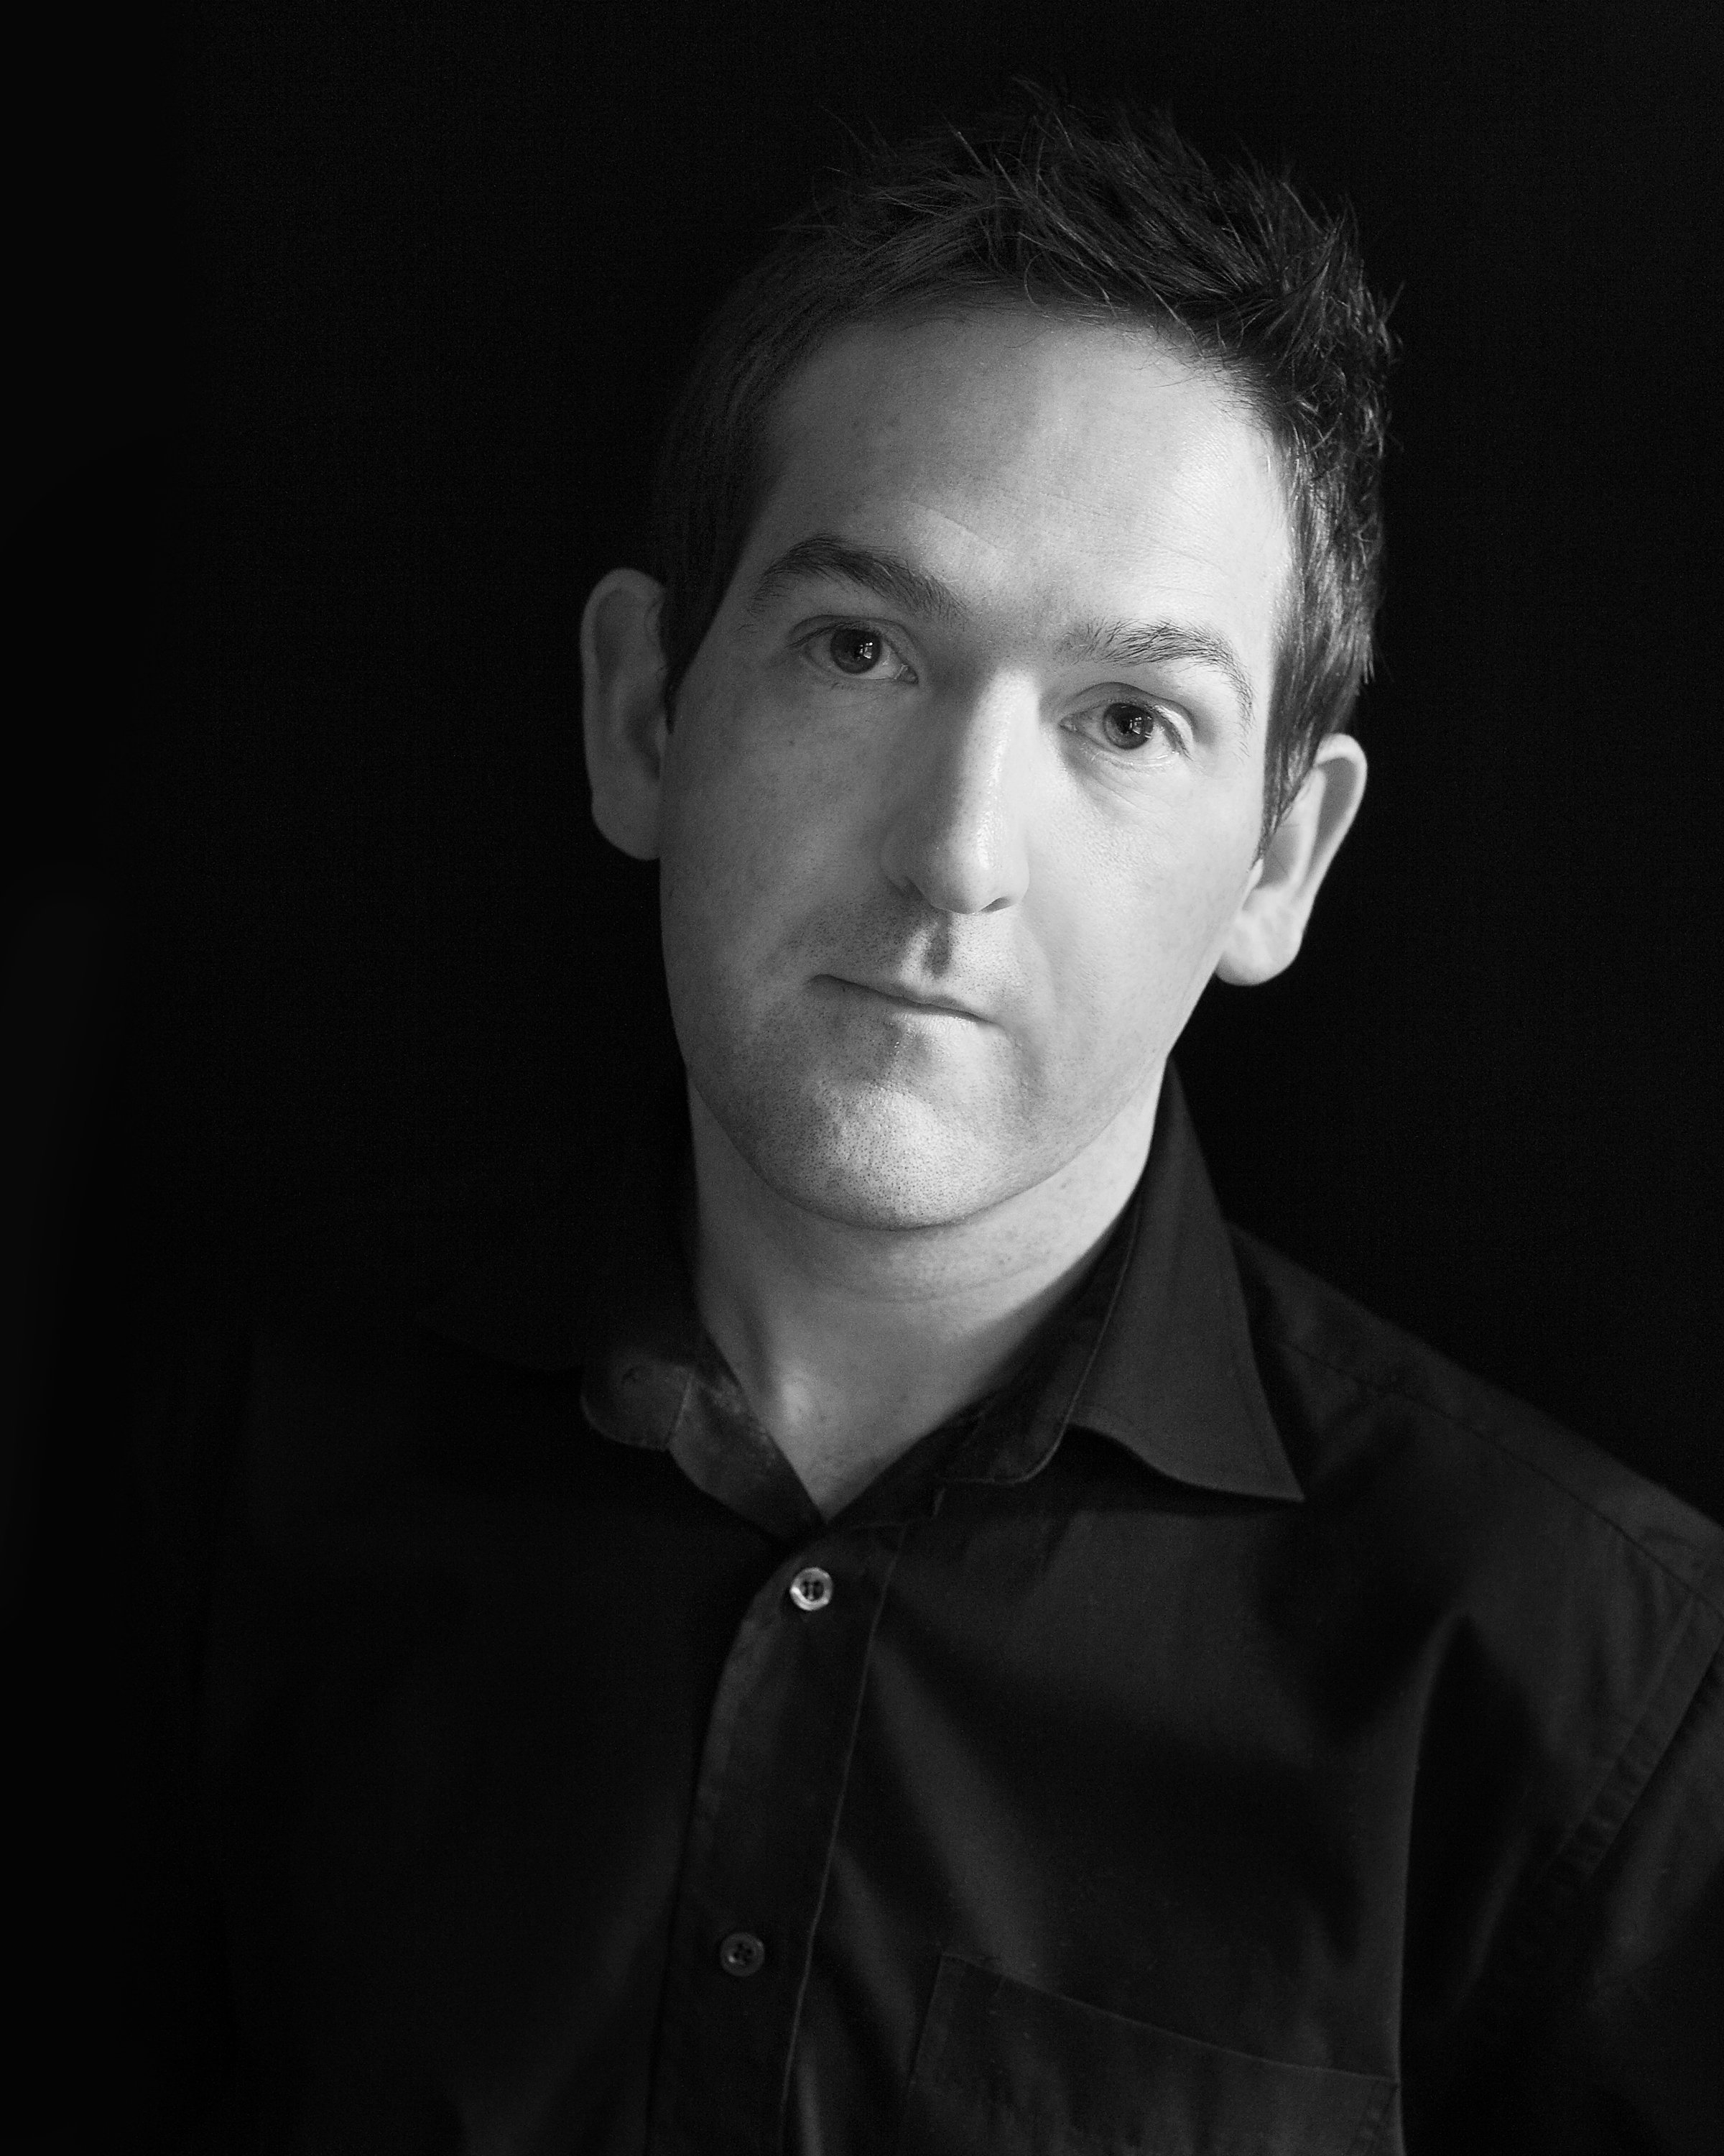
Cherryville Lodge
Cherryville
Lackagh
Co. Kildare
(086) 0592511.
Hair: Brown
Eyes: Brown/Hazel
Weight: 13 stone / Waist 34 / Slim build
Height: 5 11 Playing age 35-45
Vocal: Tenor
Equity: Member No: 1471737 / Full voting member IFTA
Agent: TEFACTORS Fintan Cullen 086 3086400
THEATRE:
The Hostage IRA Volunteer Dir. Sean Judge
A Life Desmond Drum Dir. Sean Judge
Juno and the Peacock Johnny Dir. Sean Judge
Late Arrival Des Dir. Padraig J. Dunne
Bouncers Ralph Dir. Sean Judge
Conversations on a Homecoming Liam Dir. Sean Judge
Philadelphia here I come Gar Public Dir. Sean Judge
Borstal Boy Charlie Dir. Sean Judge
Passion of Jerome Caretaker Dir. Sean Judge
Lieutenant of Inishmore Christy Dir. Sean Judge
Cripple of Inishmann Doctor Mc Sharry Dir. Sean Judge
Beyond Therapy Bruce Dir: Mary O’Doherty (Panto)Beauty and the Beast Merchant Dir. Brian Brady
(Musical) Oliver Mr. Bumble Dir. Mona Conroy
(Panto) Aladdin Genie Dir. Arthur Clarke
FILM:
I Went Down Barman Dir. Paddy Breathnach
Angela’s Ashes Coal Man Dir. Alan Parker
Tiger Tale Nurse Dir. John Boorman
Inside I’m Dancing Garda Dir. Damien O’Donnell
Eight Ball Taxi Man Dir. Peter Toft
The Time Keeper Time Keeper Dir. Alan Lawlor
The Ordinary Man Jimmy Dir. Alan Lawlor
Turning Point Interview Man / AD1 Dir. Alan Lawlor
Women’s Aid Wife Beater Dir. Linsey Corrigan
Psychosis-Psychosis Pre- production (cast in Main role)
TELEVISION:
Fair City Doctor RTE
Fair City Ambulance Man RTE
Fair City Man in pub RTE
Fair City Man on Street RTE
Fall Out Contamination team COCO television
Podge & Rodge Desmond RTE
Seachtar Na Casca British Soldier TG4
Love /Hate II Doctor RTE
TRAINING
Masters of Arts in Drama & Therapy, NUI Maynooth.

