BROADCAST RESUMÉ
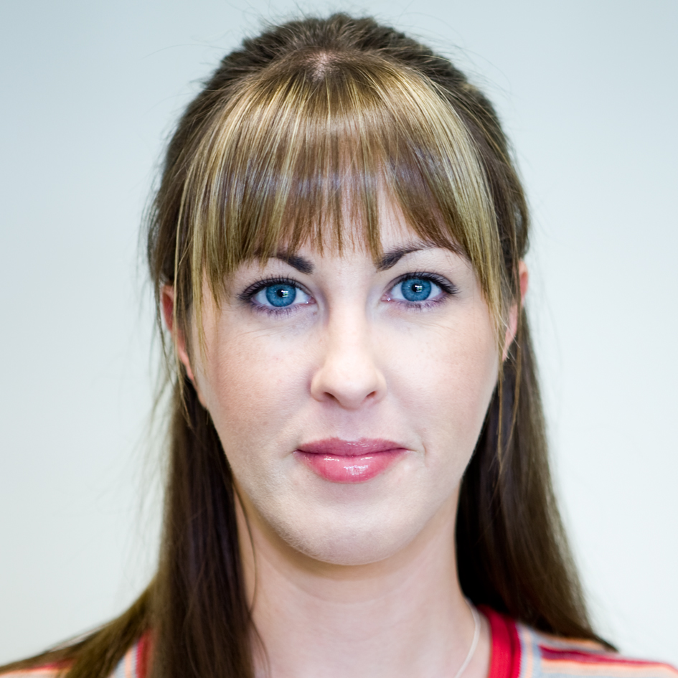
Grace Feeney
Cahertymore
Athenry
Co. Galway
Tel: 087-8348705
Email: gracefeeney@eircom.net

2007 – 2010: Riverside Television – Full Time Employee

Experience:

Féilte (2 x 14 Part Series) – RTÉ/TG4
Researcher/Production Co-ordinator/Camera Operator

Nationwide - RTÉ
Researcher/Camera Operator/Sound Recordist


Geantraí - TG4
Production Assistant


Operation Transformation (Series 1) – RTÉ
Camera Operator/Editor (Web)


Operation Transformation (Series 3) – RTÉ
Studio Technician/Co-ordinator

Citroen Showjumping Ireland Premier – TG4
Camera Operator


Super Garden - RTÉ
Sound Recordist/Location Technician



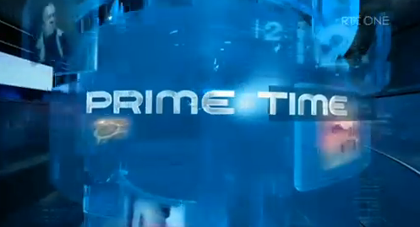
Prime Time - RTÉ
Sound Recordist

Celtic Connections - TG4
Assistant Editor

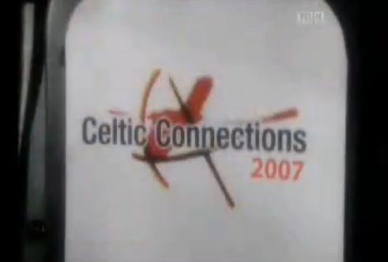
Showhouse - RTÉ
Outside Broadcast Technician/Sound Recordist



Nuacht - RTÉ/TG4
Camera Operator/Editor/Sound Recordist


Ceol ar an Imeall - TG4
Sound Recordist/Camera Operator

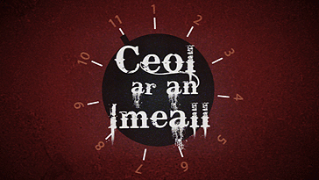


BBC Horse Racing - BBC
Sound Recordist

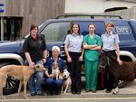
Animal Clinic - RTE
Jimmy Jib Assistant

Celtic Crossroads - Public Broadcast Stations, USA
Sound Recordist

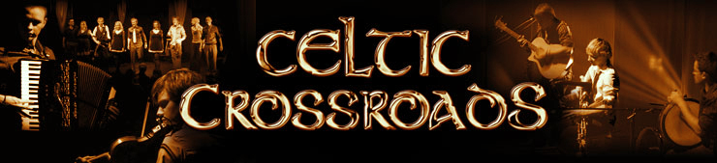

2007
Northern Ireland Elections – RTÉ/TG4
Sound Recordist


Celebrities Go Wild - RTÉ
Sound Recordist


Point Depot Advert – MTV/E4
Camera Operator/Editor



Film:

2005
Cré na Cille
Art Department Co-ordinator

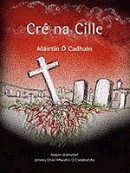

2006 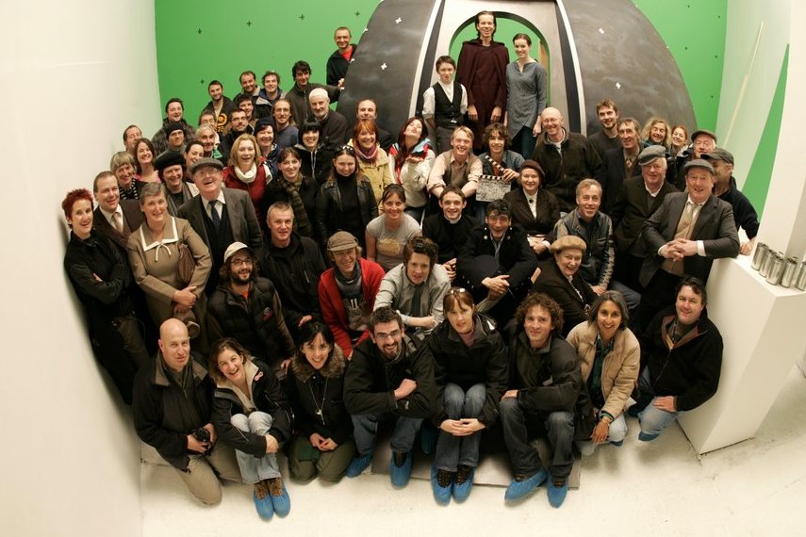
The Summer of the Flying Saucer
Locations Manager Assistant

Additional:
Mac Pro Edit Suite

 Final Cut Studio 2

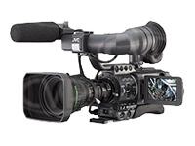JVC HD 111e Camera.

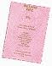Full Clean Driving Licence

 Public Service Vehicle Licence

Interests:

Cinema, Organic Gardening, Horse Riding, Travelling, Photography, Arts & Crafts.

