Nicola Coughlan

K Talent Artist Management
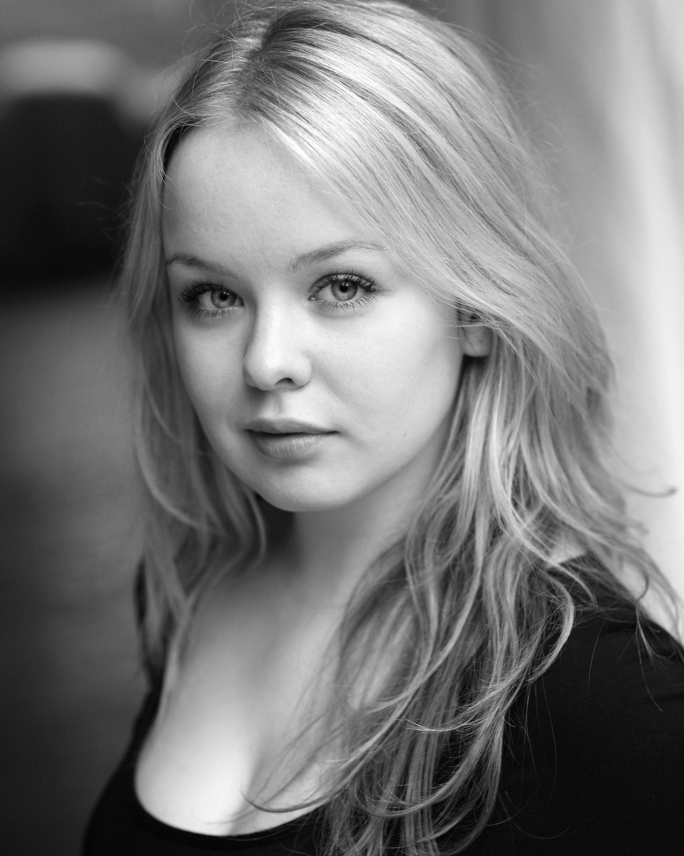
187 Drury Lane
Covent Garden
London
WC2B 5QD
Tel: 0207 4300882 / 0844 5672470
Email: hayley@ktalent.co.uk
Personal Tel: 07531949149
Personal E-mail: nicola.coughlan@gmail.com

PERSONAL DETAILS:

Height: 5’ 1’’ Eyes: Blue
Hair: Blonde Build: Petite

TRAINING
Birmingham School of Acting: MA Acting
The Oxford School of Drama: Foundation Course

PROFESSIONAL EXPERIENCE
Character Production Director
Lux Tears- Nikon Advert Laura Bellingham
Marie Callaghan Doctors (BBC) Niall Fraser
Club Girl Svengali John Hardwick
Lottie Gummi T Michael Henger
The Girl New Playwrights Workshop Dan Bird
(The National Theatre/ Birmingham REP)
Edda Legends of Valhalla: Thor (COAZ Iceland) Moe Honan

ACTING EXPERIENCE WHILST TRAINING
Character Production Director
Maggie Tulliver The Mill on The Floss Gemma Fairlie
Singer/Nephew The Caucasian Chalk Circle Vik Sivalingam
Mistress Overdone/ Juliet Measure for Measure David Vann
Eyolf Little Eyolf Lise Olson
Pam Saved Juliet Seal

SKILLS
Accents: Irish Southern (Native), RP, General American, Northern Ireland, Dublin, London, Estuary. Very Good Ear for Accents.
Singing/Instruments: Mezzo Soprano, Tin Whistle
Movement: Intermediate: Contemporary, Modern Dance, Basic: Ballet
Stage Combat: BADC Foundation Level Certificate
Other: Highly Skilled: Devising, Improvisation;
-Winner of the Outstanding Individual Performance Award at ‘Acting Up’ the Irish National University Improvisation Competition, 2008.
-Named ‘Expert Choice’ by The Stage Newspaper following Showcase, 2011.

