FIONNUALA COLLINS page 1

ACTING C.V.
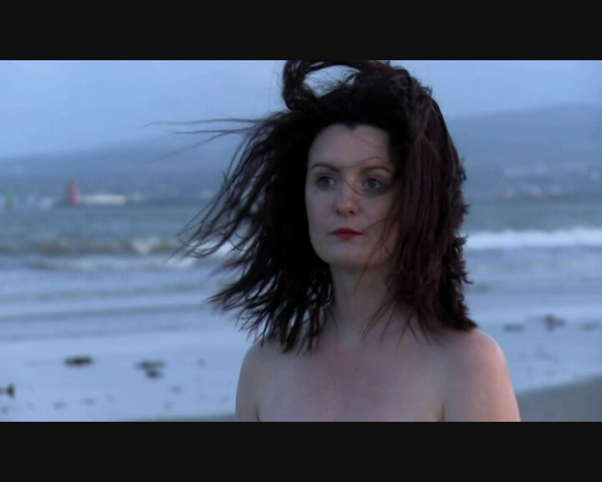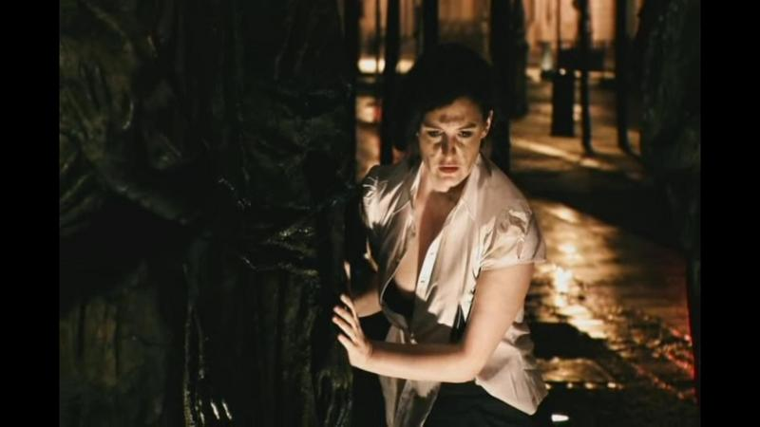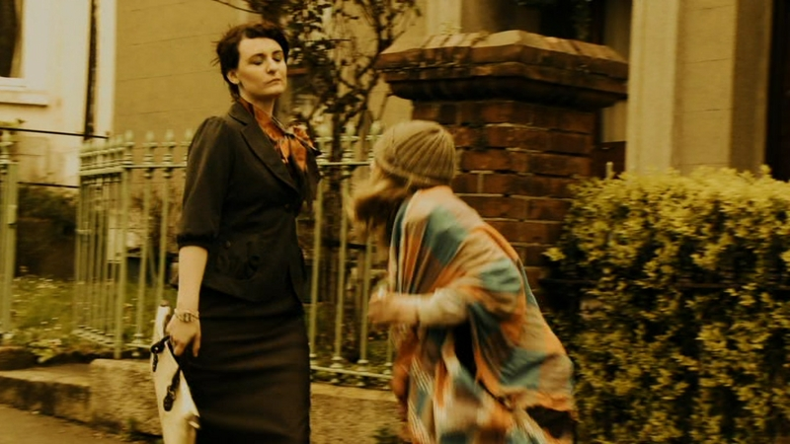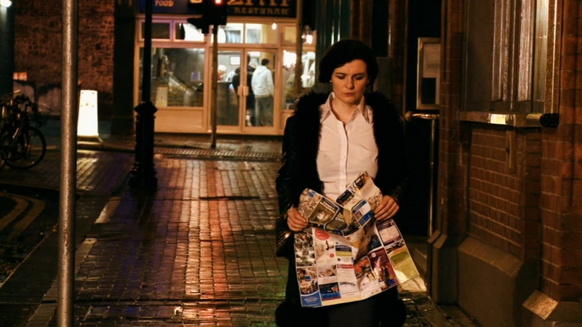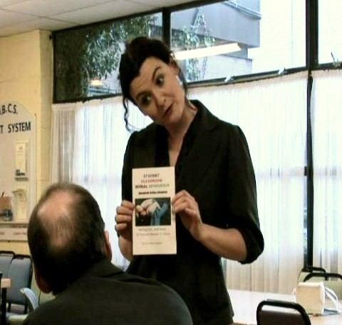

CONTACT INFORMATION

MOBILE; 00 353 86 8866363
EMAIL; actor.fin@gmail.com
WEBSIGHT; www.fionnualacollins.org

Playing age: 25-35 years Hair: dark brown Eyes: Green
Shoe size: 7 Weight: 70 kg Height: 5ft 7”

Dress size : 12

FULL IRISH ACTORS EQUITY CARD

Music: Singing blues- voice quality.
Accents: good ear, all regional Irish and English, Northern Ireland,
Australian, American, can pick up any accent given an hour or two.
Producer: Fionnuala has produced a mime comedy which has been performed in The International, Half Penny Bridge, Italian television
RAI 63, and Basil French Festival.

Writing monologues and scripts, producing my own work

TRAINING

1991-1994: Limerick School of Art & Design (Diploma in Fine Art obtained in 1994

1996- 1998: Diploma in Acting with Distinction,

1995 Gaiety School of Acting, workshop

I996-1998: Inchichore V.E.C, and London Guildhall Certificate,
Grade 12 with Honours.

2007 Certificate in Presenting,
from The Bil Keating Centre

Constantly working in any films and learning
how to express different emotions...

FILM WORK

PROJECT DATE ROLE DIRECTOR

“The Fifth Dimension” 2010, December Faith (lead female) Ciaron Davies

"Like We Used To" 2010, September, Lady Jane Ciaron Davies.

"The Picnic" 2010, September, Isobelle lead Ensaad Nacer Fawzi

"Monkey" 2010, August Miss Young Alan Lambert

"Sunday Drive” 2010, July, Eileen Toibin Oisin Mac Coille

"Atoms for Peace" 2010, May, Doctor Daniel Martin

"Director Hector” 2010, April, Brigid David Mc Connon

"Demaskus" 2010, April Mother Delores Steven Battle
(Music Video)

" In Mourning" 2010, March-April Lead Valerie Gavin Duffy

"The Walk Home" 2010, March Mother Elena Steven Flanagan

"Refuge" 2010, March Secretary Donal Foreman

"Smokes" 2010, March Mrs Doran Debbie Sheridan
(Vice Principal)

"Liquidators" 2010, February Maureen Delaney Tiarnan Lee

"From Darkness 2009,August Lead Marianne Ensaad Nacer Fawzi
to Light”

"Up and Dowm" 2009, March Lead Carla Ensaad Nacer Fawzi

"Death Shall have 1995, June Lead Rita Joey Martin
no Dominion"
(Scotland)

COMMERCIAL WORK
PROJECT DATE ROLE

Property Partners Dec 2005 1940’s Woman lead
“Merry Christmas,
RTE” Dec 2001 woman with lover

“Club Orange Add” March 2002 worker

TELEVISION WORK
PROJECT DATE ROLE DIRECTOR

“Glenroe”,
Dublin, 2001 Trudi various
RTE,

"Glenroe",
Dublin , RTE 1997 Garda Quinn, various

"Glenroe",
Dublin, RTE 1995 Maeve various

COMMERCIAL WORK
_________________________________________________________

PROJECT DATE ROLE

Property Partners Dec 2005 1940’s Woman lead

“Merry Christmas,
RTE” Dec 2001 woman with lover

“Club Orange Add” March 2002 worker

THEATRE

PROJECT DATE ROLE DIRECTOR COMPANY

“La Sirena d’irlanda" 2003 Finne Gil Pidoux
Toured Italy, many
Shows, Musical

“Alice in
Wonderland”
Samuel Beckett 1998 Tweedle Dee Selina Cartmell
Theatre, Trinity
College,

“Alice in the 1997 Tweedle Dee Selina Cartmell
Wonderland”
Player's Theatre,
Trinity College,

“Yerma” 1997 Yerma/ Understudy Roisin Flood

“The Irresitible 1997 Flake Brian O’Hare
rise of Arturo Ui”

“Twelfth Night” 1997 Officer Derek Chapman

PERSONAL

SPECIAL SKILLS

I have strong improvisational skills, have worked as a artist, mime artist, and actor. Great mimic. Can perform any accent. Proficient in most styles of combat, I keep to a strict fitness regime so am experienced in running, swimming, yoga and aerobics. I can also perform stunts. I paint on canvas with oils, brush and knife.

I am an intense and enthusiastic actor, enjoy playing hard edged characters and try to push myself to the limit. I have extra skills in sword work, martial arts. No job is too big or small and I am happy to be involved in a production whatever the role. I am intelligent, highly motivated, organized, have great focus, never complain and don’t need sleep. My motto is that “There is no such thing as stress, no problems, only solutions.”

Horse riding since 8 years old, worked in stables for free lessons, and still riding horses, jump, and horse race. Fencing, Archery, and all type of fighting skills, Karate, studied Psychology and find it helps with analysing character dimensions.

crying on cue, studying psychology self taught (House full of books, I love how the mind works), singing, very good voice, ( Derek Chapman was my voice teacher) really positive outlook, important that when working anywhere you are part of a team, grounded, down to earth, hard working, give 150 percent to any acting work, mime, great expression. This business is my passion. Painting, I'm also an artist. Horse riding, swimming,

