Eugene Sushchyy 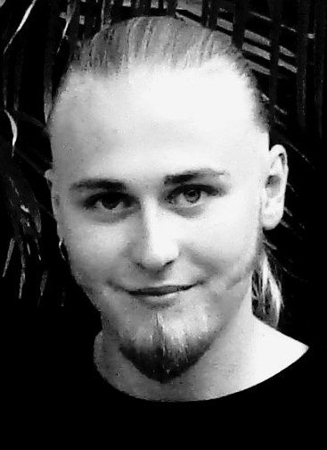
Education and Skills:

In 2009 I have graduated with distinction from a 2 year Higher Certificate course in Make-up for Film, TV and Theatre, from Institute of Art, Design and Technology (IADT), Dublin, Ireland.
On this course I have learnt a very broad range of skills, including:
• Beauty make-up,
• Theatrical make-up,
• Body painting,
• Facial hair knotting,
• Special make-up effects,
• Prosthetics and prop creation using gelatine/silicone, plaster moulds, etc.
In October 2009 I have also completed a 7-week Make-up FX and Prosthetics Creation course in Neill Gorton Prosthetics Studio, Chesham, England.
Here I have received practical training in:
• Sculpture techniques, detailing and texturing.
• Life-casting: clean-up and mounting.
• Moulding life-casts in silicone.
• Producing positives in fibreglass, plaster and fast-cast resin.
• Sculpting and moulding basic appliances.
• Casting appliances in gelatine and silicone.
• Prosthetic application.
• "Baphomet"(the final project of the course), was displayed at IMATS 2010, London,
in the museum section.
It is now exhibited in the National Wax Museum, Dublin.

• “ The Shocky Horror Show” was an article about the Wax Museum, including photographs of me and some of my work was featured in the “Sunday Mirror” national newspaper (November 28th 2010).

Work Experience:

• “Jacob” (2008) College film. (Make-up FX artist).
• “39 Years” (2009) College film. (Make-up FX artist).
• “Insida” (2009) Short film. (Make-up artist).
• “Mirrorman” (2010) Short film. (Prop maker).(Short film selection. Cannes Film Festival)
• “Anamnesis” (2010) Short film. (Make-up FX artist).
• “Absolut Gay Theatre Festival” (2010) Promotional Photo shoot. (Make-up artist)
• June 2010- February 2011: Worked in the Dublin “National Wax Museum” as a Prop-Maker.
• “Wrath Of The Titans (2012)”. 17th March 2011. (On-set prop-assistant). London.
• “Modified” (2012) Feature film. (Special Make-up FX Artist, Prop maker). London.
- An article on Modified was featured in “Bizarre” magazine, March 2012 issue 186.
• Two recent silicone pieces, “Preserved Gloria” and “Deformed” were displayed in IMATS London 2012 in the museum section. February 3rd-5th.

